Release Highlights

* Tech Routers can create customer interactions (technical and non-technical) using the same case form as regular agents.

New Features

Create Tech Router Custom Interactions

Tech Routers can now create Customer Interactions on the same form they will use to create cases in Service Desk. Details are below!

Details

* The “General” Area Path will need to be selected for Post Sales incident tracking
  1. Click “+Case” (located on the right side of the banner)
  2. Click “Active case”
  3. Set Area Path to “General”
  + TIP: If “General” does not appear, click the circle to the right of the field, and select “Show All Area Paths”

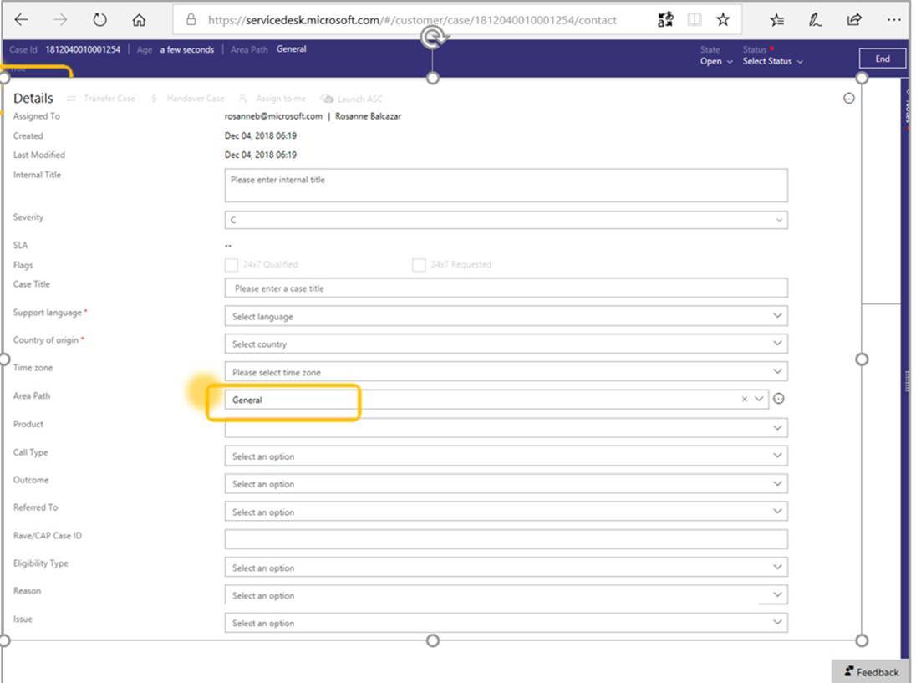

* Fields not used for Incident Tracking:
  + Internal Title
  + Severity
  + Case Title
  + Time Zone

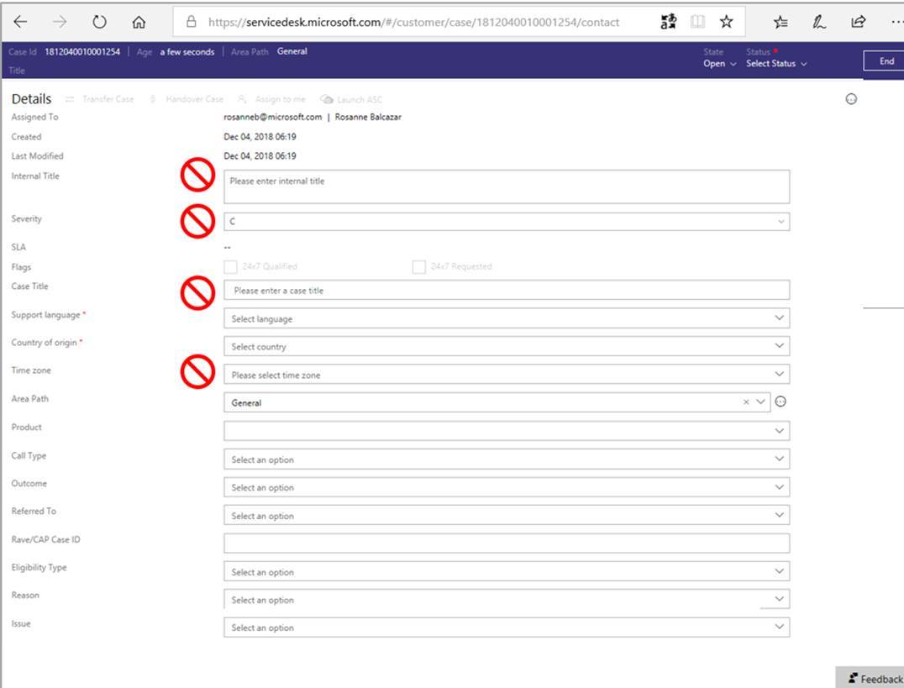

* Five fields are required in order to save an incident and are identified by a red asterisk. Attempting to save an incident without these fields being completed will result in a red error banner displayed at the top of the page.
  + Support Language
  + Country of origin
  + State
  + Status
  + Notes

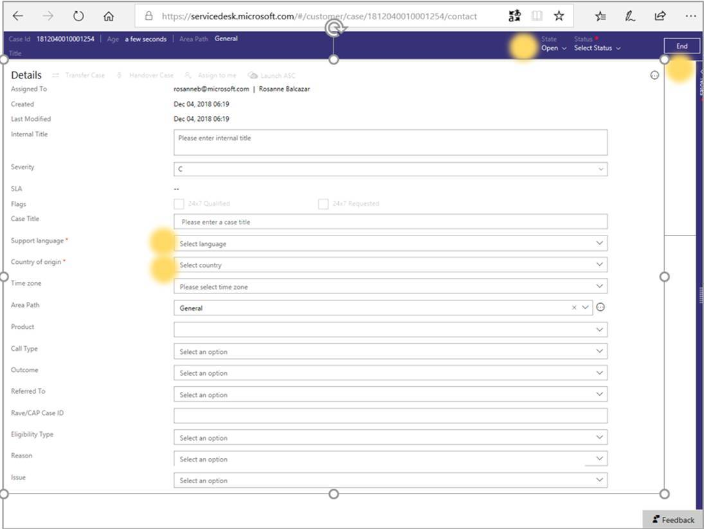

* Choosing a Topic: To Select the Topic of a case, follow the steps below:
  + Click “Area Path”
  + Under the “General” path, select the corresponding topic

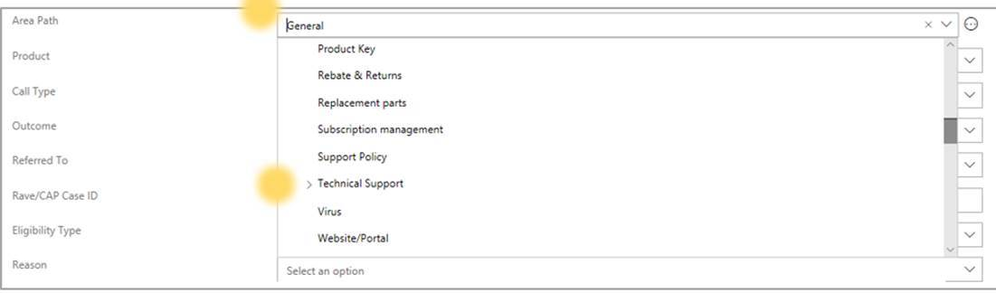

* When entering an interaction, there are four fields that must always be completed.
  + Product: Select the product that corresponds to the customers issue.  The issue does not pertain to a product type then select “none”
  + Call type: Select the call type that corresponds to the phone line the customer called.
  + Outcome:  The outcome, relates to the advocate took to handle the call.  Options include, Transfer Cold, Setup Call back, Solution Provided, etc.
  + Referred to: Select further details on how you processed the incident, example: where you sent the call, or the type of support case created

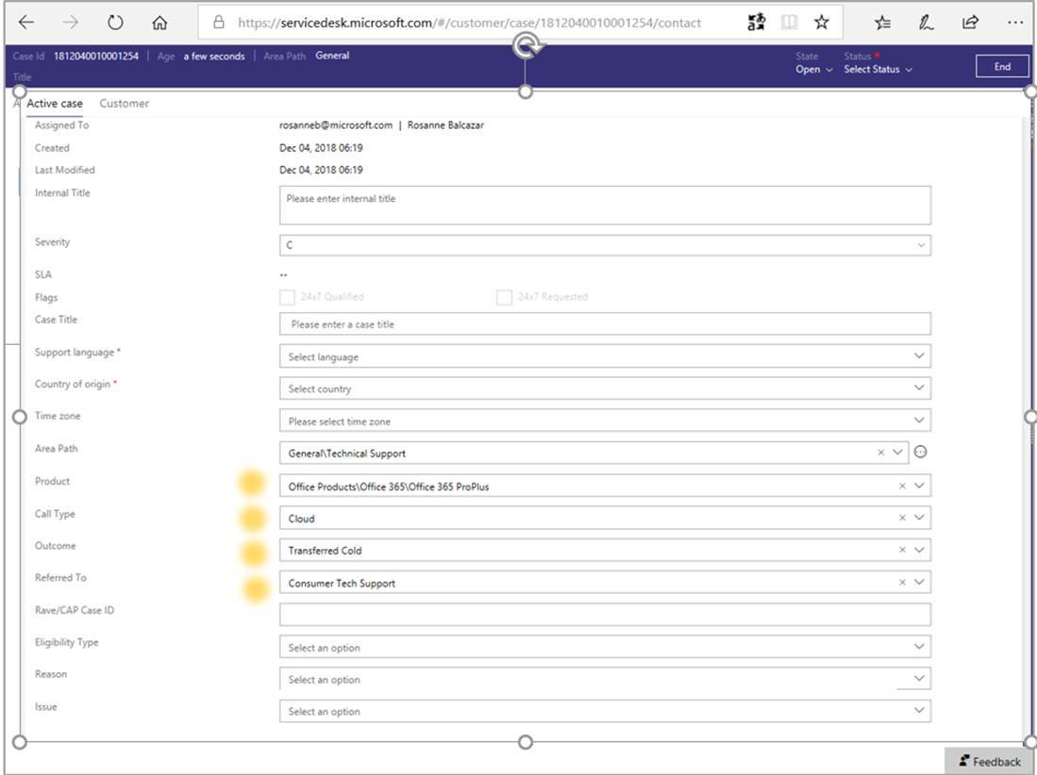

* Saving an Interaction:  State, Status and notes fields are required.
  + State: Set the case to “Closed” the majority of the time.  Only set to “Open” if the customer is expected to call “you” back with information about a PA issue or some other issue that “you” are assisting with
  + Status:
    - Resolved External: Use this field if you redirected the caller to another team or if tracking a case that was created for the caller
    - Resolved: If “you” resolved an issue, such as a product activation issue, then select “Resolved.”
  + Notes: Enter a few words describing the interaction. Examples: “Transferred to Consumer”

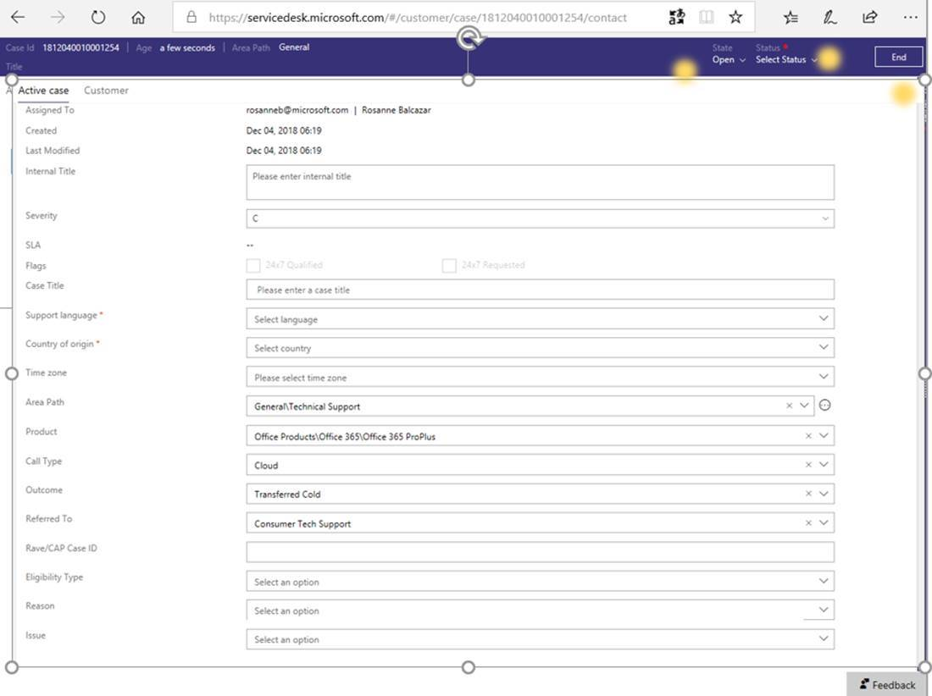

**Service Desk Taxonomy Definitions**

* + Refer to the SD Tracking for Tech Routers Taxonomy KB article for additional details: [KB Article: 4033085](https://na01.safelinks.protection.outlook.com/?url=https%3A%2F%2Finternal.support.services.microsoft.com%2Fen-us%2Fhelp%2F4033085&data=02%7C01%7CAmy.Hafen%40microsoft.com%7C7bd8b239ac2f4b4523c108d65ae52561%7C72f988bf86f141af91ab2d7cd011db47%7C1%7C0%7C636796337565274992&sdata=mXPaPOhnoWSbao58yO6Yv7Qs96ir%2Fz2AZ22U4R0dRSg%3D&reserved=0)